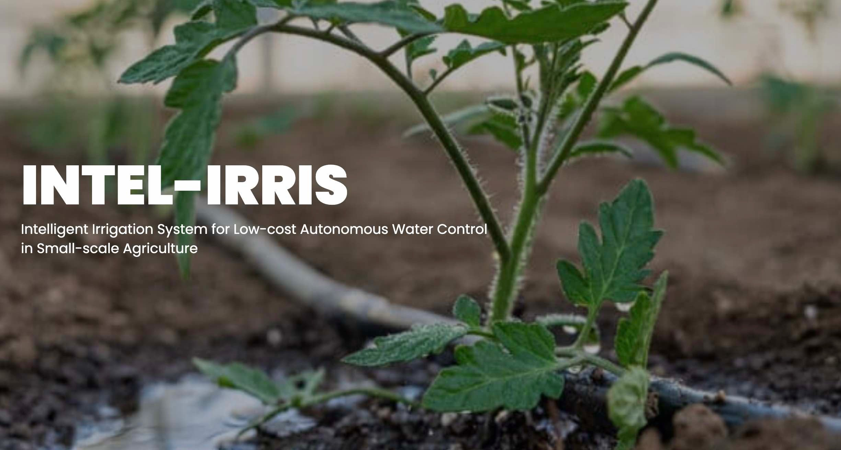
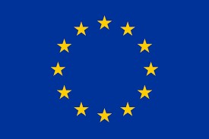
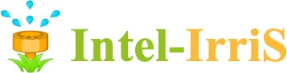
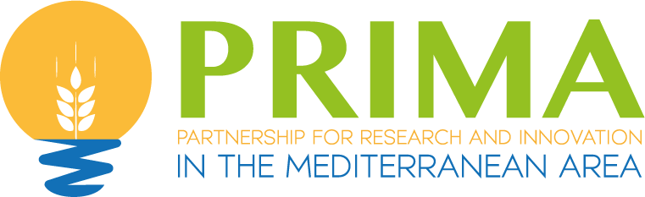

Intelligent Irrigation System for Low-cost Autonomous Water Control
in Small-scale Agriculture

The INTEL-IRRIS coding challenge with IIWA

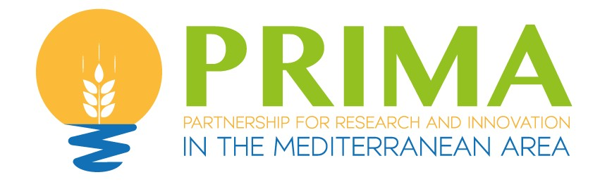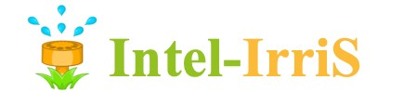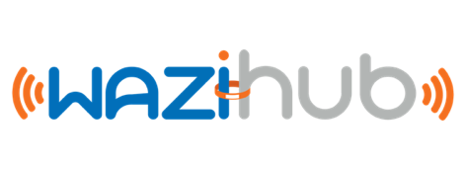Prof. Congduc Pham
http://www.univ-pau.fr/~cpham Université de Pau, France

IoT – from idea to reality

- INTEL-IRRIS is a project to build an autonomous system to optimize irrigation targeting smallholder farms
- The INTEL-IRRIS starter-kit consists of a soil humidity sensor device and an IoT gateway to collect data
- The INTEL-IRRIS Irrigation WaziApp (IIWA) is an embedded application running on the INTEL-IRRIS IoT gateway itself
- IIWA is the core of the "intelligent Irrigation in-the-box" & "plug- &-sense" INTEL-IRRIS approach
- Its objective is to enhance the irrigation indication by applying sensor calibration models with soil/plant/weather parameters
Prof. Congduc Pham
http://www.univ-pau.fr/~cpham
- This INTEL-IRRIS coding challenge is open to developers to improve the IIWA application

Knowledge Database
Decision Support System
AI
Machine Learning

Irrigation technique
Soil type
Geographical area

Crop type

Weather

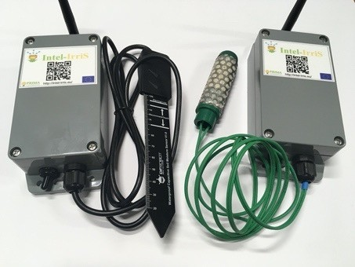
Embedded Intelligence
Prof. Congduc Pham
http://www.univ-pau.fr/~cpham

Multiple kwnowledge streams
Build datasets

Agronomist

Technology experts

Pilot fields

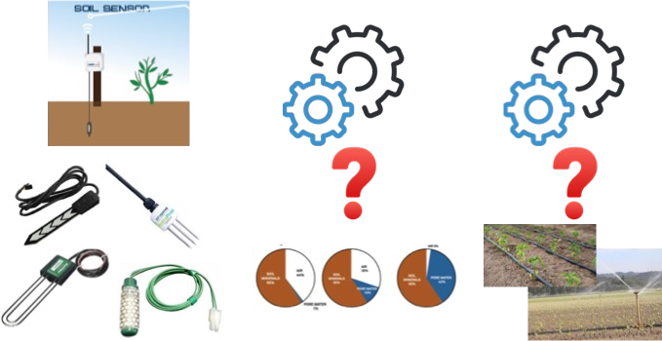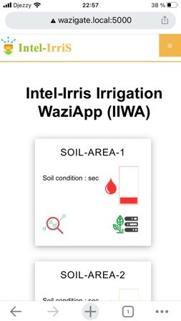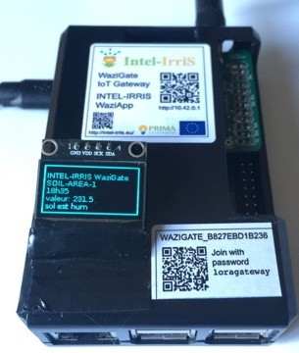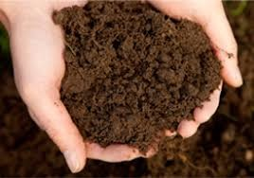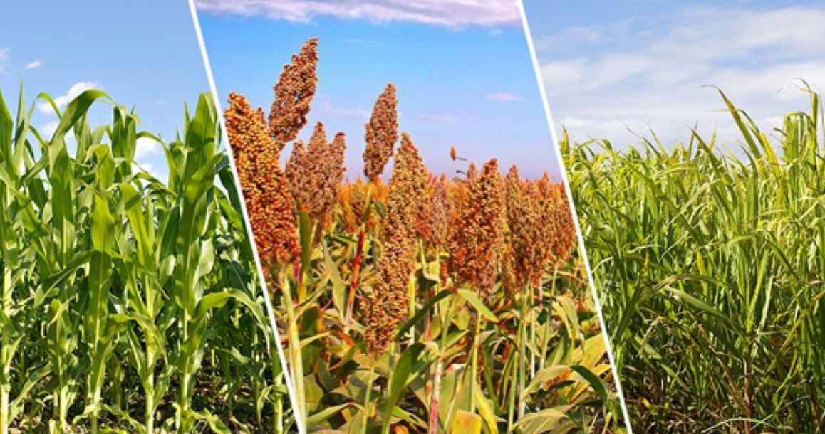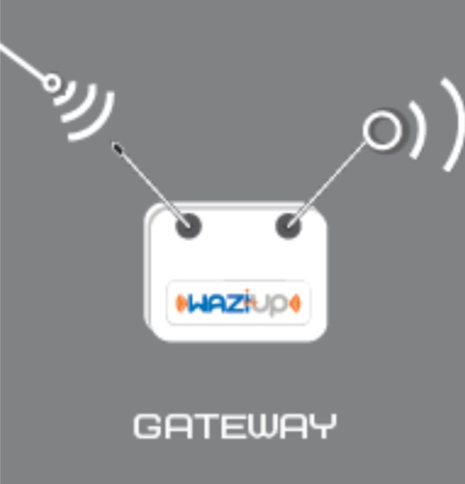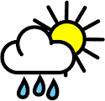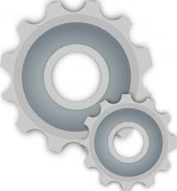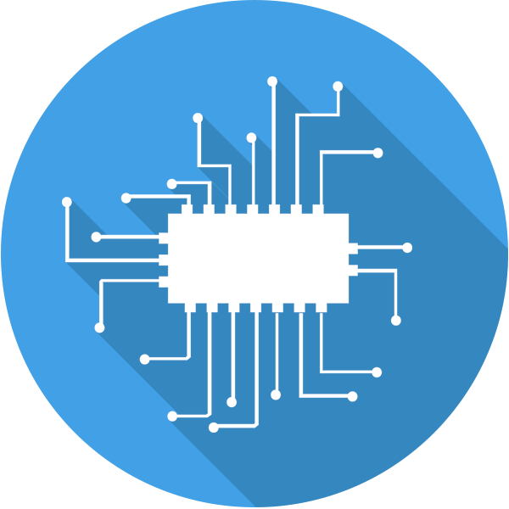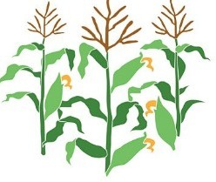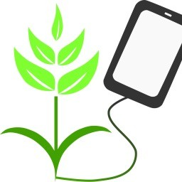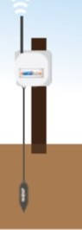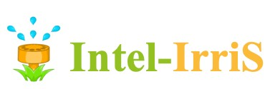
AI/ML
Prediction models

Prof. Congduc Pham
http://www.univ-pau.fr/~cpham

- 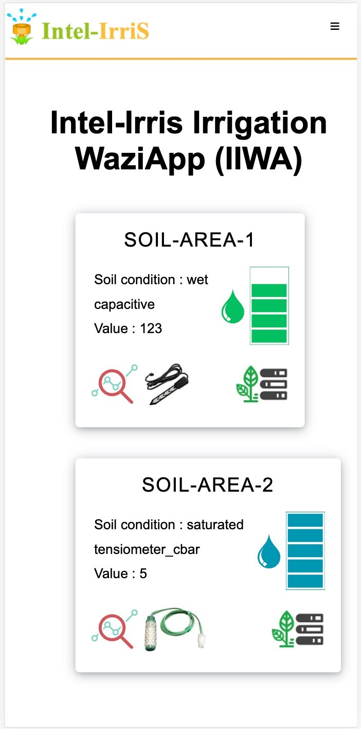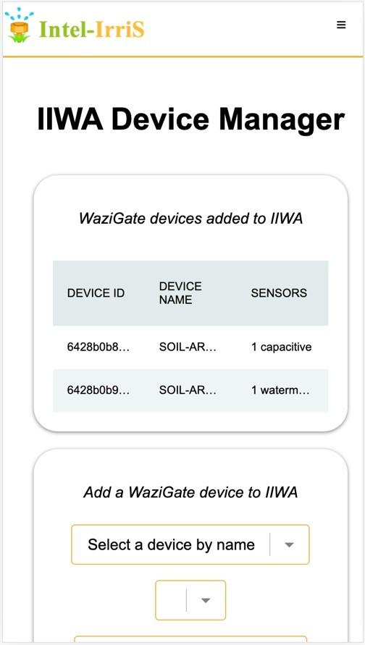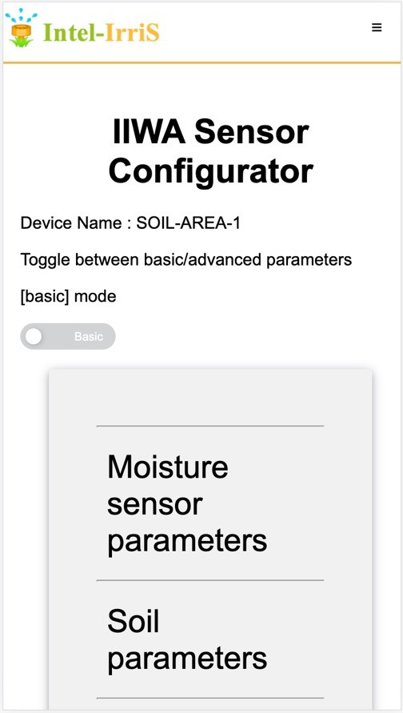Dashboard, Device Manager and Sensor Configuration

- Competitors will propose improvements on the IIWA application
- Several contribution coding categories are defined
  - Categoty 1: User Graphical Interface
  - Categoty 2: Calibration of sensor data
  - Categoty 3: Processing & transformation of sensor data
  - Categoty 4: Integration of agriculture data & knowledge
- The current IIWA code is available, competitors can use it as a skeleton to propose improvements
- It is written in Python+Flask with some HTML/JavaScript code
Prof. Congduc Pham
http://www.univ-pau.fr/~cpham
- The code can be run on desktop computers: Windows, Linux and MacOS operating system are supported

- Competitors can be organized in team and a team contact person must be designated
- Competitors must send an email to national contact persons listed at the end of this document
- The initial mail must indicate
  - The name and affiliation of all team members
  - The team contact person
  - The coding category the team will be working on
- The coding challenge will end on July 31st, 2023
Prof. Congduc Pham
http://www.univ-pau.fr/~cpham
- Team can register until July 1st, 2023

- The current IIWA code for the coding challenge can be downloaded from GitHub repository https://github.com/CongducPham/PRIMA-Intel-IrriS-IIWA-challenge
- Competitors can optionally fork the repository
- Read installation instructions in build-local folder
- Use a desktop/laptop computer to develop IIWA improvement, although IIWA will normally be run on a RaspberryPi
- Propose, develop, test and document the improvement
- Avoid as much as possible complex software dependencies that may limit the genericity of the contributions
Prof. Congduc Pham
http://www.univ-pau.fr/~cpham
- However, if the whole dependencies can be easily installed locally it can be accepted

- As INTEL-IRRIS mainly targets an autonomous system for smallholder farms, relying on Internet connectivity to get access to resources on Internet should be avoided
- However, for the coding challenge, contributions relying on Internet connectivity can be accepted provided that they do not represent the main improvements
Prof. Congduc Pham
http://www.univ-pau.fr/~cpham

- Team must submit the following items
  - The complete code of the new & improved IIWA application
  - It can be a .zip archive or a link to a GitHub repository
  - The code must be self-contained so that it can be run & tested by the jury members on their desktop/laptop computer
  - A report in .pdf explaining the technical improvements and what they bring to the IIWA application. The page limit is 15 pages, including figures and screenshots
  - A short video showing the main improvement on the IIWA application
  - A special attention must be made to clearly indicate what open-source code have been used and integrated into the main IIWA code if this is the
Prof. Congduc Pham
http://www.univ-pau.fr/~cpham
case (it is not necessary to list well-known open-source libraries needed as dependencies for the contributions)

Prof. Congduc Pham
http://www.univ-pau.fr/~cpham

- Start: now
- Team can register until July 1st, 2023
- End: July 31st, 2023
  - contributions must be submitted by mail

- Algeria
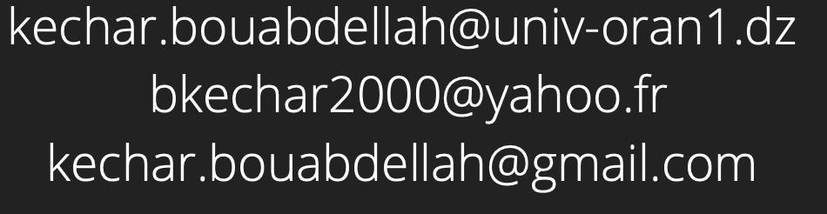
  - Pr Bouabdellah Kechar, University of Oran 1
- Morocco
  - Pr Kamal Baraka, ENSA Safi
  - Pr Chahbouni Othman, ENSA Safi & Université Cadi Ayyad
Prof. Congduc Pham
http://www.univ-pau.fr/~cpham
